How strongly does lift-off latency scale with the duration of the spoken sentence, one-to-one or less? The impact that sentence duration has on the amount of time it takes a participant to lift their finger off the START key is what is being examined (Morey et al., 2022). β represents the population unstandardized slope of lift-off latency on sentence duration. The null hypothesis is that lift-off latency scales one-to-one with the duration of the spoken sentence (H₀: β = 1). The alternative hypothesis is that it scales less than one-to-one (H₁: β < 1). I predict that lift-off scales less than one-to-one with sentence duration. This is because listeners can anticipate the direction of a sentence before it ends. For longer sentences, anticipation results in the response coming sooner relative to where that sentence ends.
I ran a simple linear regression between lift-off latency and sentence duration at α = .05 level of significance. Both variables are continuous, with duration as the predictor and lift-off latency as the outcome. The slope is the quantity of interest, which is being tested against a value of 1. I am using regression instead of correlation because the research question asks about the slope and testing it against one-to-one requires real units.
Linearity was checked by examining the scatterplot between the two variables. The relationship was approximately linear with no sign of curvature. The independence assumption was violated since trials within a participant were correlated. This means that the standard errors would likely be understated, resulting in a narrower confidence interval. Significance was also easier to reach. The homoscedasticity was checked by examining the residuals-vs-fitted plot. This assumption was not met because the spread was skewed toward large positive residuals, meaning the residual variance was not constant. The slope is still interpretable, but the confidence interval should be read with caution. Upon examination of the Q-Q plot of residuals, they departed from normality, violating the normality assumption. Because of the large sample size, inference about the regression is robust to non-normal residuals. Since the research question requires a ms-per-ms relationship and given these departures, I retained the raw metric instead of transforming. I also checked for any influential observations, and none materially affected the fit.
Lift-off latency increased with sentence duration, but less than one-to-one, b = 0.741, SE = 0.007, 95% CI [0.727, 0.754], t(36,097) = 107.4, p < .001. The 95% confidence interval excludes 1, so the slope is reliably less than one-to-one. Thus, I reject the null hypothesis of one-to-one scaling. Every additional millisecond of sentence duration was associated with approximately 0.74 additional ms of lift-off latency. Sentence duration accounted for around 24% of the variance in lift-off latency (R² = .24). Figure 1 displays the relationship between sentence duration and lift-off latency.
Figure 1
Lift-Off Latency as a Function of Sentence Duration
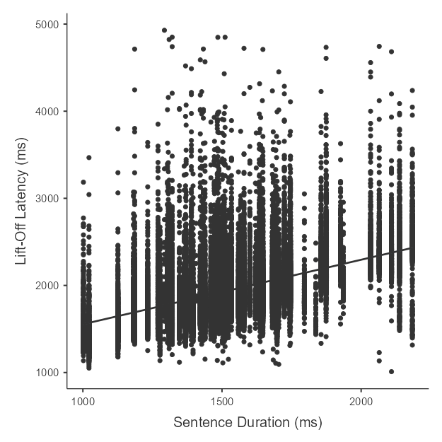
My prediction that lift-off latency scales less than one-to-one with sentence duration was supported. It scaled at a rate well below 1, about 0.74 ms per ms. This means that the gap between the end of a sentence and the participant’s response shrank as the sentences got longer. Thus, lift-off latency does not track sentence duration one-to-one. It is important to note that the independence and heteroscedasticity violations most likely made the true confidence interval wider than reported. So, the precision is overstated. However, because the interval is so far below 1, the conclusion about the slope still holds even if the interval was considerably wider.

References
Morey, R. D., Kaschak, M. P., Díez-Álamo, A. M., Glenberg, A. M., Zwaan, R. A., Lakens, D., Ibáñez, A., García, A., Gianelli, C., Jones, J. L., Madden, J., Alifano, F., Bergen, B., Bloxsom, N. G., Bub, D. N., Cai, Z. G., Chartier, C. R., Chatterjee, A., Conwell, E., … Ziv-Crispel, N. (2022). A pre-registered, multi-lab non-replication of the action-sentence compatibility effect (ACE). Psychonomic Bulletin & Review, 29(2), 613–626. https://doi.org/10.3758/s13423-021-01927-8

